CompTIA A+ 220-901 and 220-902 Cert Guide, Academic Edition
First Edition

Copyright © 2017 Pearson Education, Inc.
ISBN-10: 0-7897-5653-6
ISBN-13: 978-0-7897-5653-4
Warning and Disclaimer
Every effort has been made to make this book as complete and as accurate as possible, but no warranty or fitness is implied. The information provided is on an "as is" basis. The author and the publisher shall have neither liability nor responsibility to any person or entity with respect to any loss or damages arising from the information contained in this book or from the use of the CD or programs accompanying it.
When reviewing corrections, always check the print number of your book. Corrections are made to printed books with each subsequent printing.
First Printing: July 2016

Corrections for January 16, 2017
Pg | Error – First Printing | Correction
33 | Chapter 2, Replace Figure 2-4 | Replacement Figure  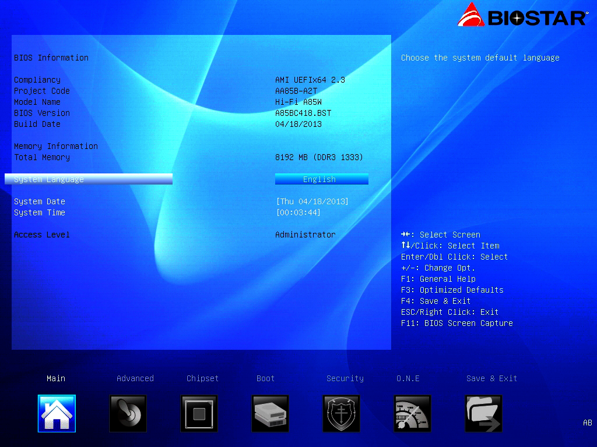
34 | Chapter 2, Replace Figure 2-7 | Replacement Figure  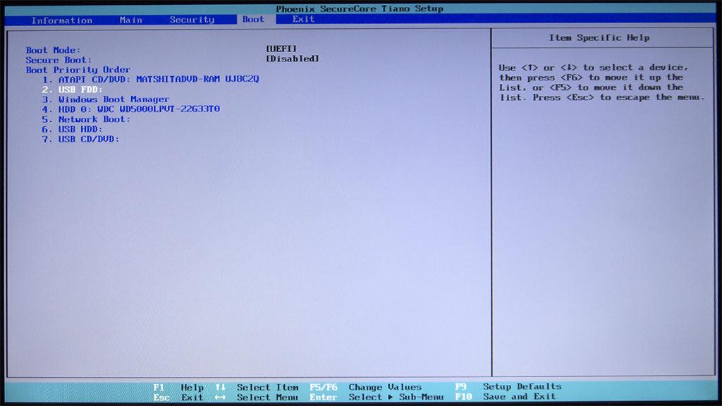
37 | Chapter 2, Replace Figure 2-11 | Replacement Figure  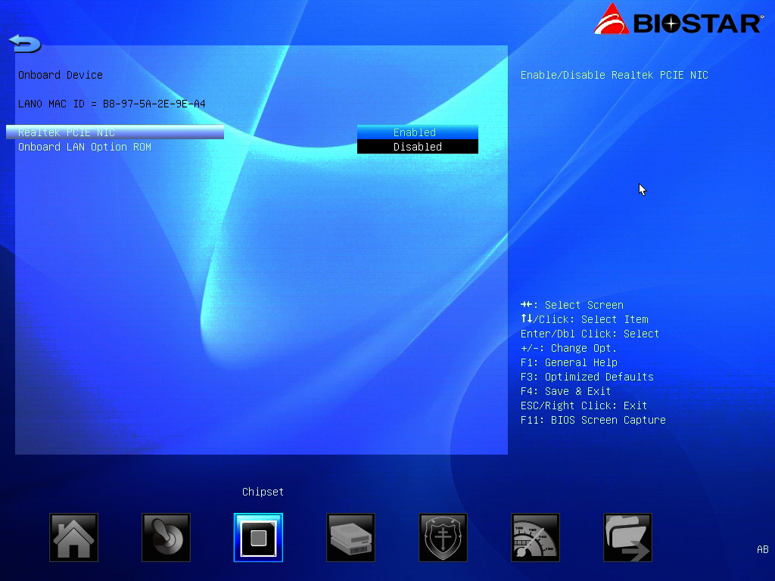
79 | Chapter 3, Answers and Explanations to Review Questions, Number 3  Reads:  3. 1. A; 2. C; 3. B. |  | Should read:  3. 1. B; 2. C; 3. A.

165 | Chapter 7, Replace Figure 7-1 | Replacement Figure  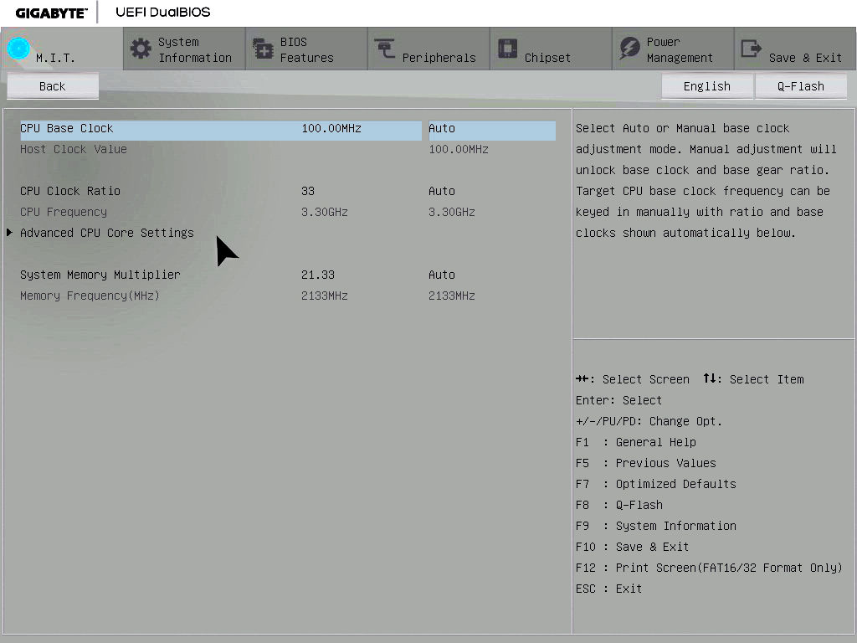
166 | Chapter 7, Replace Figure 7-2 | Replacement Figure  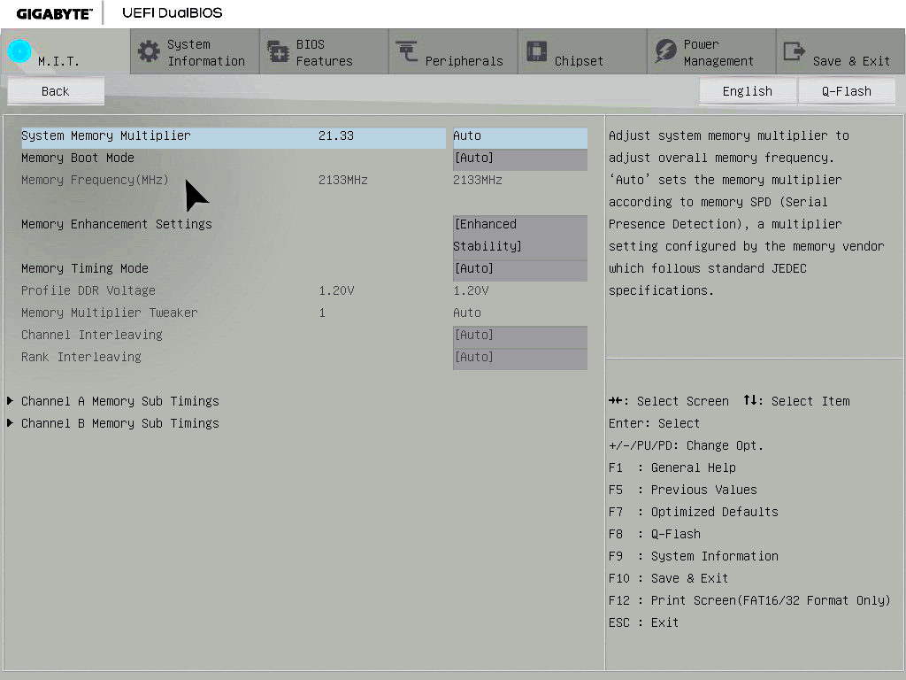

Corrections for November 11, 2016
Pg | Error – First Printing | Correction
5 | Chapter 1, Figure 1-2, Replace Figure | New Figure  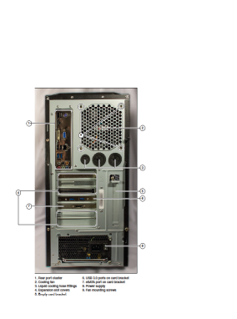
8 | Chapter 1, Figure 1-5, Replace Figure | New Figure  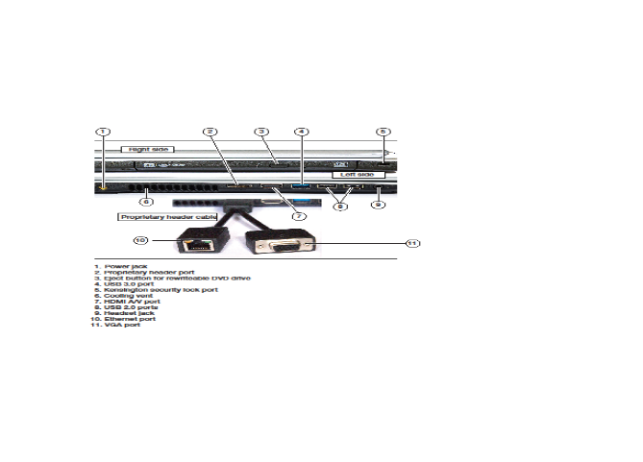

10 | Chapter 1, Figure 1-9, Replace Figure | New Figure  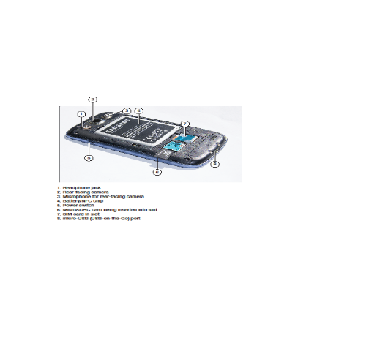
20 | Chapter 1, Question 2, Replace Figure | New Figure  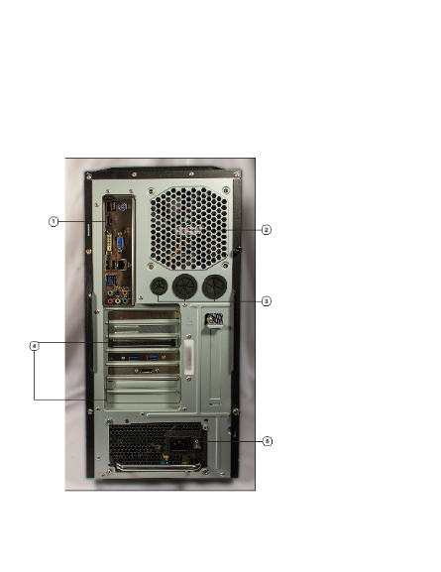

62 | Chapter 3, Table 3-2, Slot Type and Performance Columns, Line 10, 14, and 18  Read:  PCIe x2 v1 1,000MBps*  PCIe x2 v2 2,000MBps*  PCIe x2 v3 4,000MBps* |  | Should read:  PCIe x4 v1 2,000MBps*  PCIe x4 v2 4,000MBps*  PCIe x4 v3 8,000MBps*
65 | Chapter 3, Figure 3-8, Number 3  Reads:  3. South Bridgecontrols USB 2.0, Ethernet, and SATA ports on this system |  | Should read:  3. South Bridge controls USB 2.0, Ethernet, and SATA ports on this system
65 | Chapter 3, Figure 3-9, Replace Figure |  | New Figure  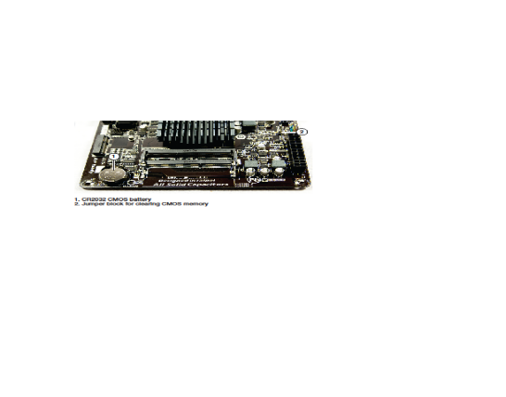
100 | Chapter 4, Figure 4-12, Replace Figure |  | New Figure  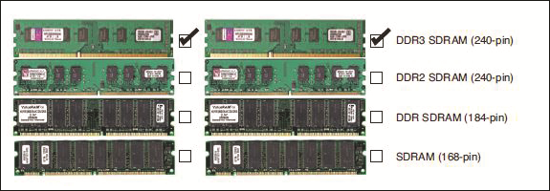
100 | Chapter 4, Figure 4-13, Replace Figure |  | New Figure  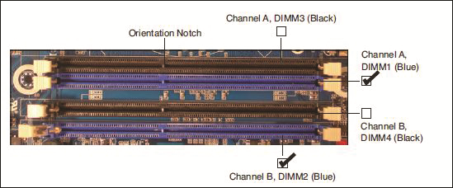
324 | Chapter 10, Answer Review Question, Question 3, Replace Figure |  | New Figure  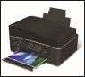
470 | Chapter 13, Figure 13-21, Number 2  Reads:  2. Shift+Delete deletes file |  | Should read:  2. ShiftDelete deletes file
471 | Chapter 13, Figure 13-22, Replace Figure |  | New Figure  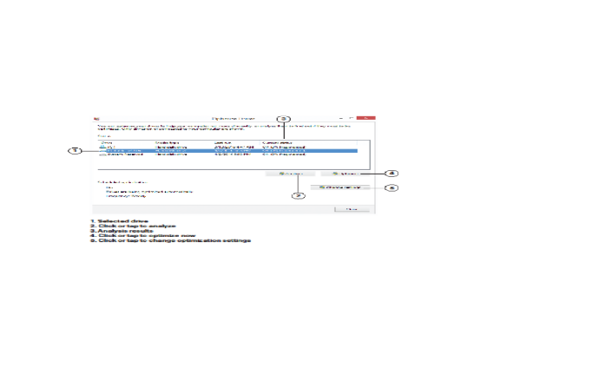
482 | Chapter 13, Figure 13-30, Number 4  Reads:  4. Step 3. Select 100%. Log out and log back in again to finish. | Should read:  4. Select 100%. Log out and log back in again to finish.
506 | Chapter 13, Figure 13-39, Replace Figure | New Figure  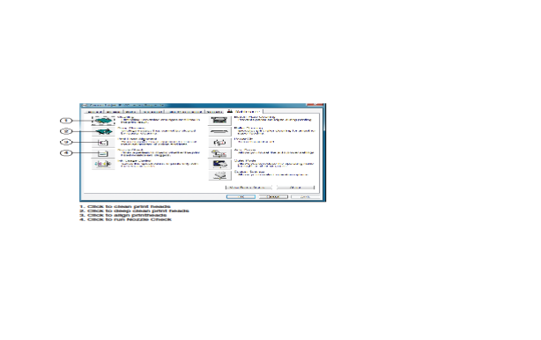

This errata sheet is intended to provide updated technical information. Spelling and grammar misprints are updated during the reprint process, but are not listed on this errata sheet.

