CompTIA A+ 220-901 and 220-902 Cert Guide
First Edition

Copyright © 2017 Pearson Education, Inc.
ISBN-10: 0-7897-5652-8
ISBN-13: 978-0789705652-7
Warning and Disclaimer
Every effort has been made to make this book as complete and as accurate as possible, but no warranty or fitness is implied. The information provided is on an "as is" basis. The author and the publisher shall have neither liability nor responsibility to any person or entity with respect to any loss or damages arising from the information contained in this book or from the use of the CD or programs accompanying it.
When reviewing corrections, always check the print number of your book. Corrections are made to printed books with each subsequent printing.
First Printing: August 2016
Corrections for January 16, 2017
Pg | Error – First Printing | Correction
39 | Chapter 2, Replace Figure 2-4 | Replacement Figure  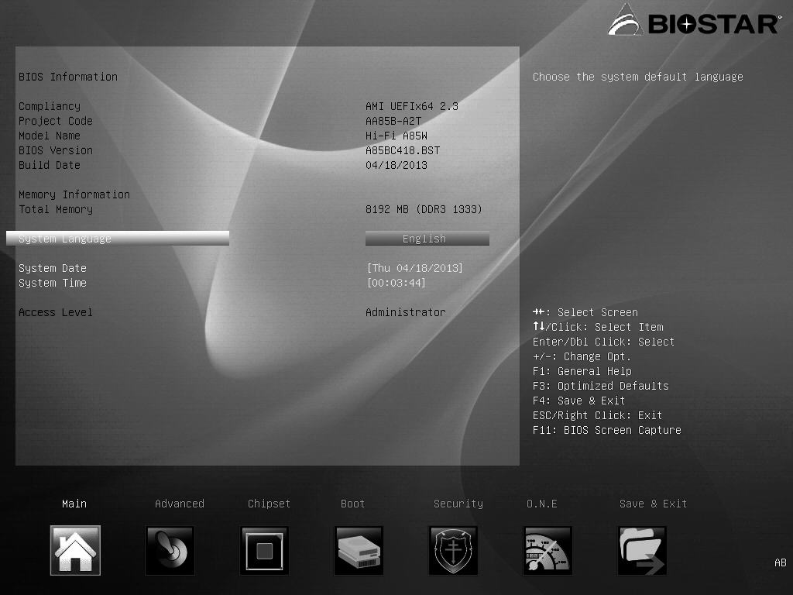
41 | Chapter 2, Replace Figure 2-7 | Replacement Figure  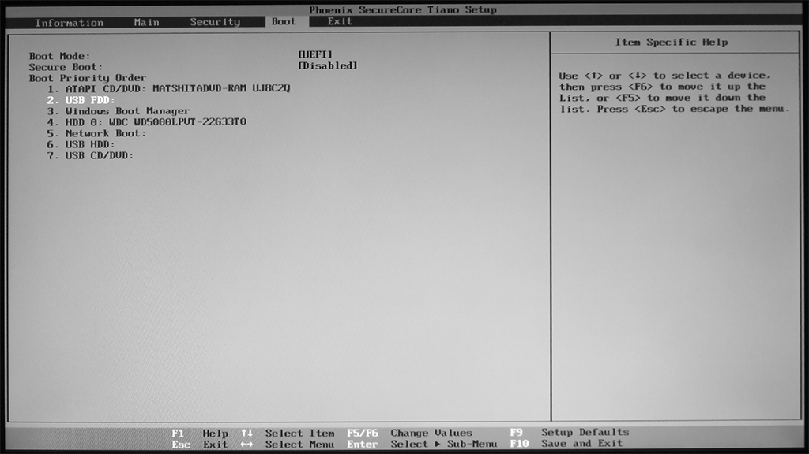
45 | Chapter 2, Replace Figure 2-11 | Replacement Figure  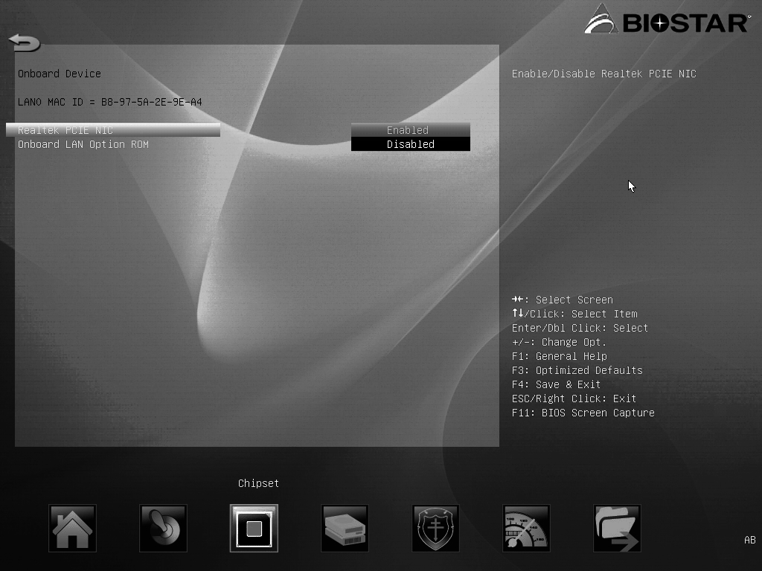
97 | Chapter 3, Answers and Explanations to Review Questions, Number 3  Reads:  3. 1. A; 2. C; 3. B. |  | Should read:  3. 1. B; 2. C; 3. A.

207 | Chapter 7, Replace Figure 7-1 | Replacement Figure  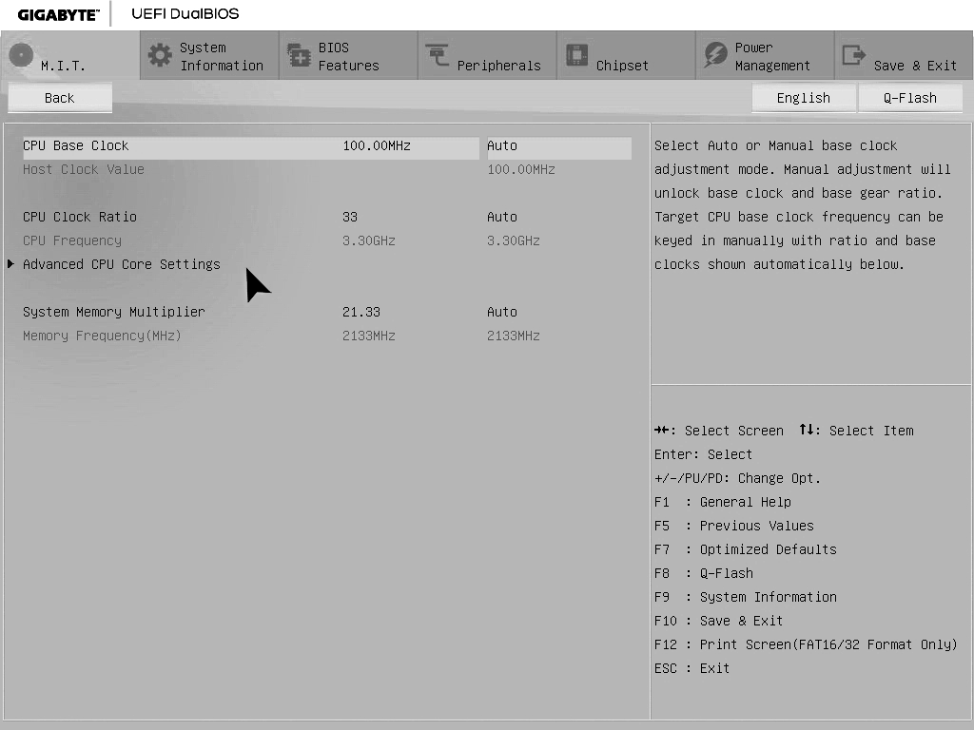
207 | Chapter 7, Replace Figure 7-2 | Replacement Figure  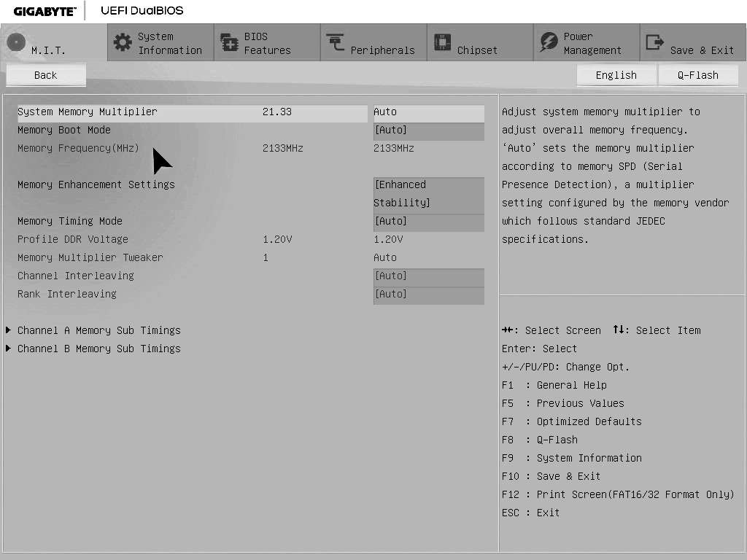

This errata sheet is intended to provide updated technical information. Spelling and grammar misprints are updated during the reprint process, but are not listed on this errata sheet.

